Sling Dynamic Include

<https://www.argildx.com/technology/sling-dynamic-include-sdi/>

In CQ or AEM, most of the pages remain static. Hence, caching of the pages is very useful with dispatchers or any other available AEM plugins/connectors.

Imagine a scenario where homepage of news agency must show the hot news, which is different for different regions, however, because of caching it is displaying the same news in all the regions. Strange!

To rescue from these, live scenarios, the application may require certain elements/components of the page to be dynamically included. In AEM, Sling Dynamic Include (SDI) provides this functionality.

**Note:** The following step1 & step2 need to be performed on publish instance.

**Step1:**

Install Sling Dynamic Include Bundle using the following steps:

1. [Download](https://sling.apache.org/downloads.cgi) the Dynamic Include bundle.
2. Open the bundles using http://<host>:<port>/system/console/bundles
3. Click on install/update button in the right corner of the screen

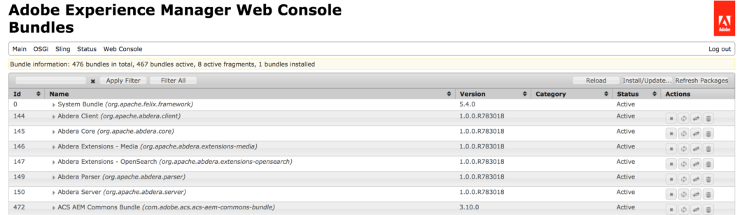

1. Check the Start Bundle checkbox and browse the location where the bundle is downloaded and Click on install/update button

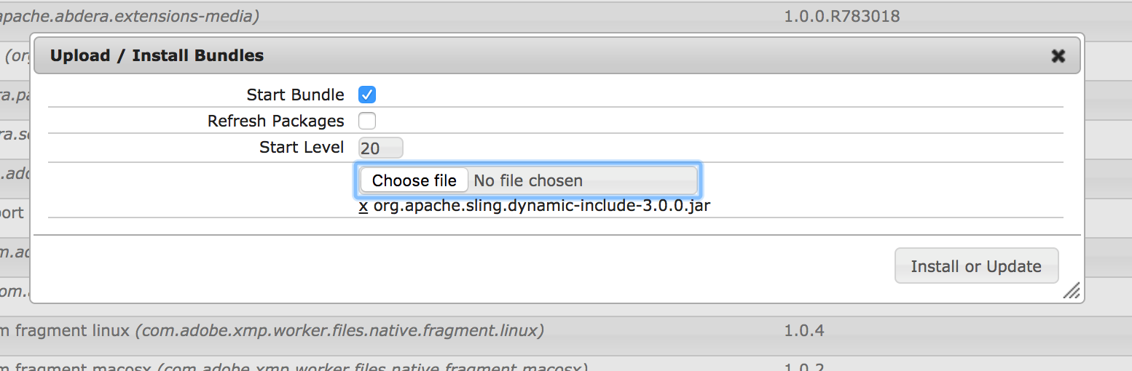

Once the installation of the bundle is completed, verify it by searching Dynamic Include. It should be in an active state.

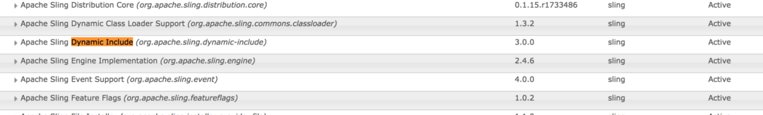

**Step 2:**

After installation of the SDI bundle, the next step is to configure the component to be dynamically included.

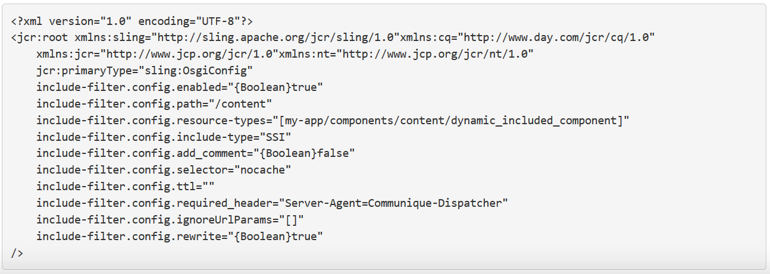

SSI – Server Side Include

ESI – Edge site Include

**Step 3:**

After completion of Step 1 and Step 2 on publishing instance, Dispatcher configurations need to be updated as explained below:

1. Include(If already present, make sure uncommented) the mod_include module in Apache Web server’s httpd.conf file:



1. Update virtual host configuration file
2. Find the following lines in the dispatcher.conf file



modify as below 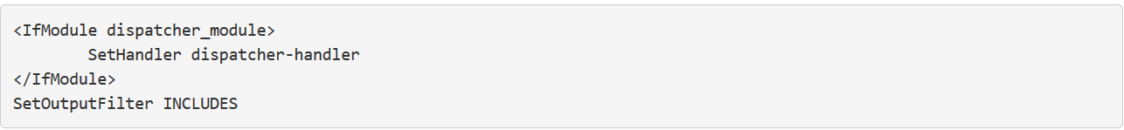

1. Add Includes to Options directive:

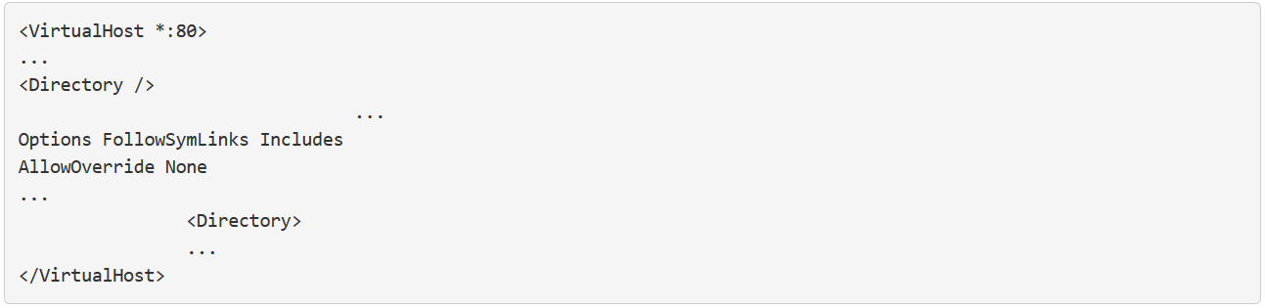

1. Update the ‘httpd.conf’ to enable SDI.

a. Add “Includes” to Options directive to enable SSI includes used by Sling Dynamic Include

b. Specify what file types are to be processed by Includes filter.

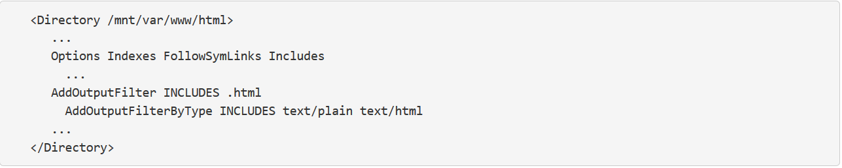

1. Update ‘rules.any’ or ‘dispatcher.any’ depending where the cache rules are defined for the publish instance.

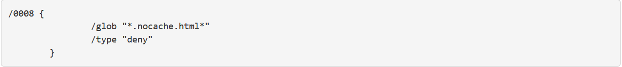

Make sure the selector ‘nocache’ used here is same as defined in OSGI config (include-filter.config.selector = ‘nocache’) explained in Step 2.

1. Restart the server using any of the below commands:

sudo apachectl restart OR sudo service httpd restart

**Verification**

After setting up the SDI, it’s time to verify the changes. Follow the below steps.

1. Right click and open the page source on the webpage where the component is dynamically included.
2. In the page source, search for SDI includes tag.
3. A component configured for SDI will be replaced with SDI tags as shown below:x

